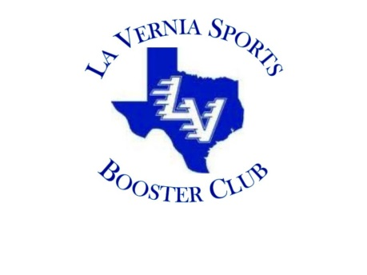

2021 La Vernia Sports Booster Club
Scholarship Application

Applicants Name:

Address:
Street

City State Zip

Cell Phone Number

Applicants: Please note that you must complete this Scholarship Application in its entirety, to include the 3 recommendation letters, your LVHS transcripts, and essay to be considered by the La Vernia Sports Booster Club (LVSBC) Scholarship Committee. Applications must be turned into the high school counselor’s office by the end of the school day on April 20, 2021. Incomplete or Partial applications will not be considered by the LVSBC Scholarship Committee.

Eligibility Requirements:
- Must be a La Vernia High School Student-athlete or trainer and a graduating senior in 2021.

- A member of the immediate family must be a member of the LVSBC for at least 2 year.

- The applicant or immediate family members must have volunteered a minimum of 20 hours for the LVSBC (no more than 10 hours per year qualify).

- The applicant must have attended a minimum of 3 General Membership Meetings.

- Must attend a College, University, or Trade School in the Fall of 2021. Scholarship winners will be awarded for the Fall 2021 semester.

- Complete all pages of the application. If you need more space to complete the answers please attach a separate page to the back of the application with your name and page number on (at) the top of the page.

- Attach a copy of your current high School transcripts with the application.

- Include 3 separate signed recommendation letters. Recommendation letters must be from:

- The Coaching staff (only one letter from the LV coaching staff);

- Faculty member (may not be a coach);

- Member of the community with knowledge of community service, leadership, and character.

Recommendation letters must be from 3 separate people.

- A 500-word essay (criteria listed below).

LVSBC MEMBERSHIP REQUIREMENTS

LVSBC Membership: List the member of the applicant’s immediate family that was a member of the La Vernia Sports Booster Club.

Members Name | Relation to the Applicant | Year(s) of Membership

LVSBC Volunteer Hours: List the events/dates/hours that you or an immediate family member volunteered to help with a La Vernia Sports Booster Club event. Attach additional sheet if needed.

Name of Volunteer | Relation to the Applicant | Event | Date | Hours Worked

LVSBC General Membership Meetings: List the dates that you (the applicant) attended an LVSBC General Membership Meeting.

Date of General Membership Meeting
Sports: List the high school sports you participated in at LVHS and any outside organizations. Check each year that you completed each sport played. An LVHS Coach will need to validate participation in LVHS sports. You will not be credited for any un-validated sports.

Sport | Year (Check each applicable year that you completed/per sport) |  |  |  | Coach Validation by Signature
 | Freshman | Sophomore | Junior | Senior

Sports Honors and Awards: List sports honors and awards received from high school, the local community, UIL, organizations associated with your school, or any outside organizations. Attach additional sheets if needed (necessary).

Sport | Honor Award (list highest achievement) | Year (Check each applicable year for the honor/award)
 |  | Freshman | Sophomore | Junior | Senior

Extracurricular Activities: List the extracurricular activities you participated in while in high school, also include the years you were involved and any offices held. This list should include societies, clubs, church groups, etc. from high school and any outside organizations.

Organization Name / Activity | Year (Check each applicable year that you participated in the activity) |  |  |  | Office Held (if Yes, include office)
 | Freshman | Sophomore | Junior | Senior

Community Service /Volunteer: Please list all of the community service activities you participated in while in high school. List the type of work performed, volunteer hours served, and school year in which you participated.

Organization Name / Work Performed | Year (Check each applicable year that you participated in the activity) |  |  |  | Number of Hours
 | Freshman | Sophomore | Junior | Senior

Letters of Recommendation: Include 3 separate signed recommendation letters. Recommendation letters should be from:

- The coaching staff (only one letter from the LV coaching staff)

- Faculty member (may not be a coach)

- Member of the community with knowledge of community service, leadership, and character.

Essay: This essay must be typed using 12-point font, Times New Roman font, and double-spaced. Include your name at the top of each page of the essay and attach the essay to the back of the completed application. The minimum word count is 500. The essay shall be based on the following:

- Describe how participating in sports at La Vernia High School has impacted you as a person and prepared you for your future.

Higher Education Plans:

What College, University or, Trade School have you been accepted to or plan to attend? _______________________________________

Please list what you plan to major/Minor in:

Major #1: __________________________________________________

Major #2: __________________________________________________

Minor #1: __________________________________________________

Minor #2: __________________________________________________
By completing this scholarship application, you are allowing the La Vernia Sports Booster Club to release your name on press releases to the media, which include all forms of social media (i.e., Facebook, Instagram, Twitter, etc.), Websites,

ff

Applicant Signature: __________________________________ Date: _____________

Parent/Guardian Signature: ____________________________ Date: _____________

